****

**SSL Certificate Installation**

Date: 20 May 2021

Author: Raunak Sharma

For further information please contact:

[support@projectobjects.com](mailto:support@projectobjects.com)  
[www.projectobjects.com](http://www.projectobjects.com)

© 2021 Project Objects Ltd

Contents

[SSL Certificate Installation 0](file:///C:/Users/POI/Desktop/SSL%20Guide%20for%20Livetrial%20or%20Live%20server.docx#_Toc72421821)

[2. Introduction 2](#_Toc72421822)

[3. Generate CSR (Certificate Signing Request) 2](#_Toc72421823)

[4. Install Certificate 4](#_Toc72421824)

[5. Binding SSL certificate to the web site 5](#_Toc72421825)

[6. Install GeoTrust Secured Seal 6](#_Toc72421826)

# Introduction

This document is primed to describe the procedure to create CSR file and then install certificate on server.

# Generate CSR (Certificate Signing Request)

Below link can be refferred to generate the CSR:

<https://www.digicert.com/kb/csr-creation-ssl-installation-iis-10.htm>

Please follow below procedure to create CSR file:

1. Go to application server
2. Open IIS > Click on Server Certificate

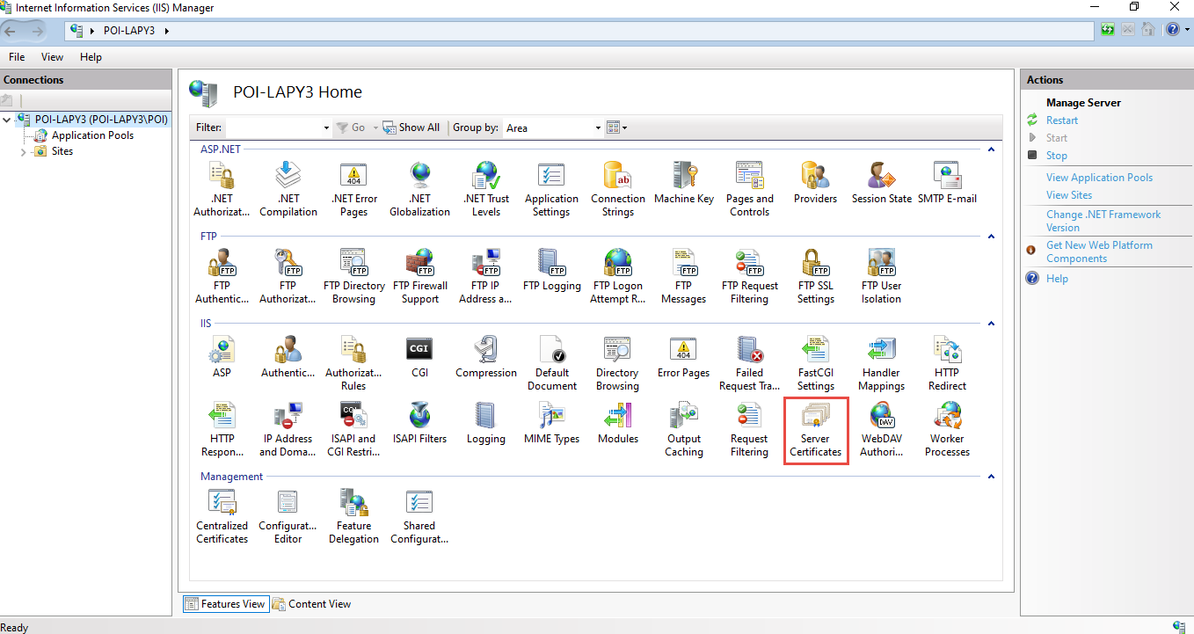

1. From Right pane, click on **Create Certificate Request**

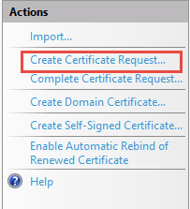

1. Insert data according to the details. Below is the example for Live-trial server

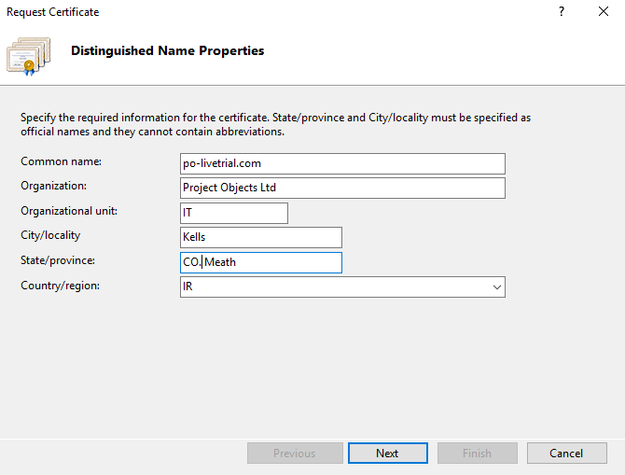

1. Click on **Next** and select **4096** in **Bit Length**

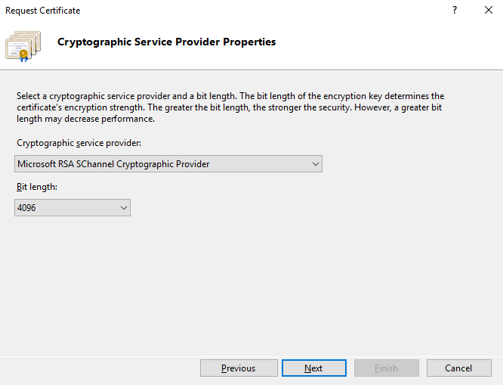

1. Click on **Next** and select location and file name to save the CSR file
2. Click on **Finish**

# Install Certificate

Below link provides information to install certificate

<https://www.digicert.com/kb/csr-creation-ssl-installation-iis-10.htm>

Please follow below procedure to install certificate on server:

1. Download your certificate from the unique secure link we provide your technical contact via email.
2. The ZIP file you download contain the SSL and Intermediate CA certificate in PKCS#7 file (i.e. ssl\_certificate.p7b).
3. Unzip the files onto the server where you will install the certificate.
4. In Windows, click **Start > Administrative Tools > Internet Information Services (IIS) Manager**
5. From the left menu, click the corresponding server name
6. In the Features pane (middle pane), under Security, double-click**Server Certificates**
7. From the Actions pane (right pane), select **Complete Certificate Request**
8. Provide the location of the certificate file and a friendly name  
     
   **NOTE:** The **Friendly Name** is a reference name for quick identification of the certificate for the Administrator.
9. Be sure that the Personal store is selected, then click OK  
     
   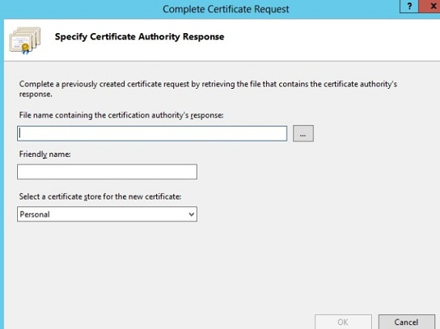

# Binding SSL certificate to the web site

1. From the **Connections** column on the left, expand the **Sites** folder
2. Select the appropriate web site.
3. From the **Actions** pane on the right, click on **Bindings**

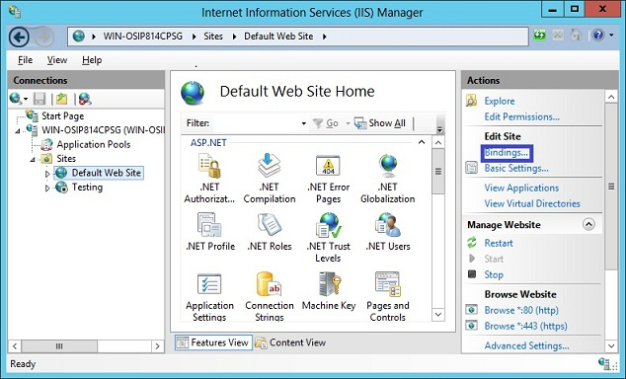

1. In the Site Bindings window, If there is no existing https binding, choose **Add** and change **Type**from HTTP to HTTPS.  
     
   **NOTE:** If there is an https binding, select it and click**Edit**  
     
   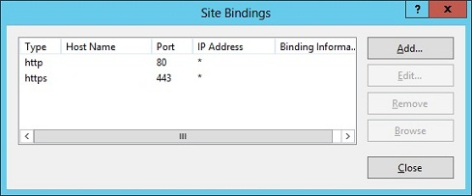
2. From the **SSL Certificate**drop down, select the friendly name for the SSL certificate that was used during installation.

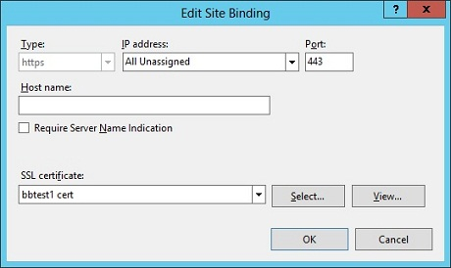

1. Click **OK**
2. To verify if your certificate is installed correctly, use the **[GeoTrust Installation Checker](https://ssltools.digicert.com/checker/views/checkInstallation.jsp" \t "_blank)**

# Install GeoTrust Secured Seal

Take advantage of the trust mark that gives customers confidence put the GeoTrust Secured Site Seal on your site today! GeoTrust Secured Seal is included with your certificate purchase.

To customize and install the seal on your web site, go to:

<http://www.geotrust.com/support/seal/agreement/installation-instructions>